# Sunshine Coast Suburb Comparison:

## Introduction:

In this report, I aim to compare and cluster different suburbs within the Sunshine Coast area of Queensland, Australia. I am looking to move to the Sunshine Coast in August 2022, and therefore would like to look for potential suburbs in which I could live which would suit my lifestyle.

Other potential users of this project would be anyone looking to move to the Sunshine Coast who would like to see how different suburbs compare with each other.

## Data Used:

Data which is utilised for this project includes:

* Australian Postcode Location Data: <https://www.corra.com.au/australian-postcode-location-data/>
* Sunshine Cost Postcode Data: <https://www.geopostcodes.com/Sunshine_Coast>
* Foursquare mapping and location data

## Methodology:

Initially, I imported the Australian Postcode Location Data, and filtered it by suburbs that existed within the Sunshine Coast Area. Following this, I removed Suburbs that were not included in location data (using the dropna() function).

With the remaining suburbs and locations, I used Foursquare API to get data regarding nearby facilities, including their location and category. I then used this to find most commonly occurring facility for each suburb.

Following from this, I used the sklearn package, and specifically the K-Means machine learning algorithm to cluster each suburb based on most commonly occurring facilities. I divided them into 3 clusters and then used the Folium package to display the result.

## Results:

There were 160 Suburbs found within the Sunshine Coast Area, which contained 517 venues, including 119 unique categories. The suburb Mooloolaba had the greatest number of venues (29), of which 24% were Cafés.

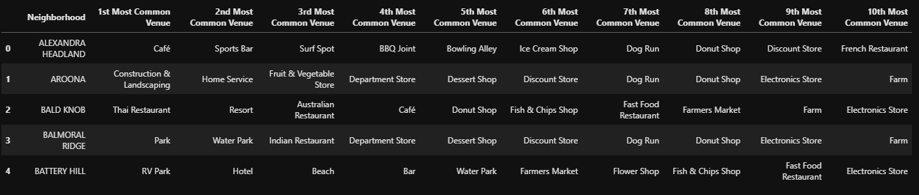

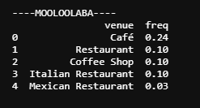

K- Means Clustering was used to cluster data points into 3 groups as seen below.

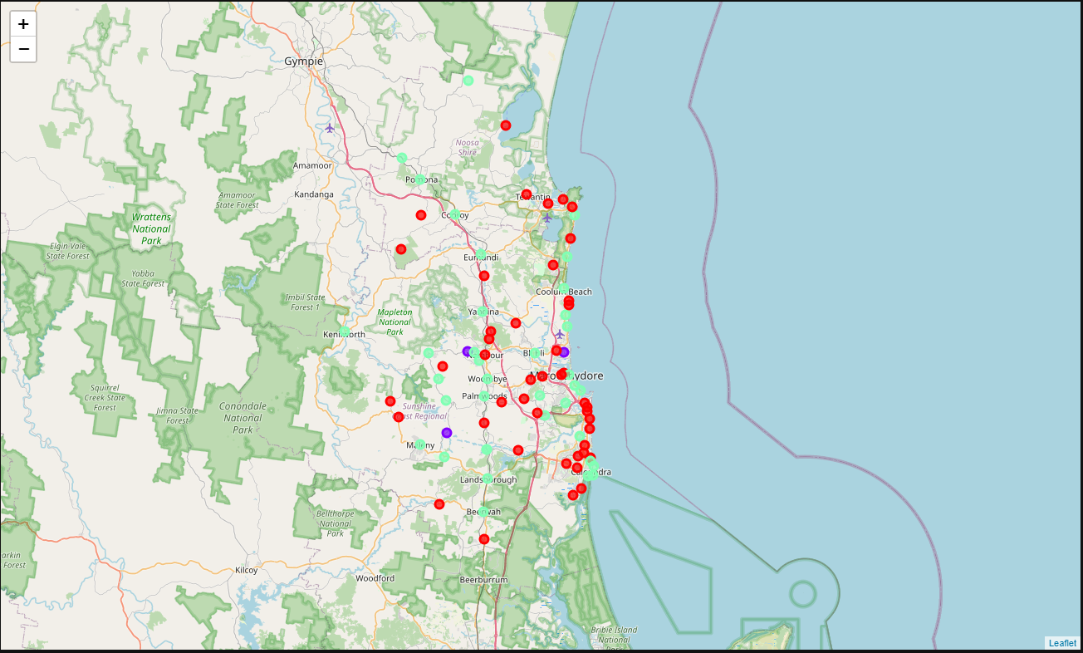

## Discussion:

I decided to use K = 3 for the K- means algorithm because this seemed to divide the coast up into two groups: Cluster 0 (red) seemed to be placed that were on the coast that were just outside of larger cities/ towns, while Cluster 2 (green) captured the coast side areas which are slightly denser such as Maroochydore and Caloundra.

Cluster 0 contained areas with higher density of Cafes, Restaurants, Bars and Stores, while Cluster 2 were smaller areas, containing resorts, lookouts, beaches and Water Parks.

Cluster 1 (purple) were outliers which had parks and water parks nearby.

## Conclusion:

Based on the above and my lifestyle goals in the near future, places identified as Cluster 0 would suit my lifestyle and would be suitable for me to settle in.